**Photo of borrower’s Small Cosmetic Shop at Samakky Market**

**Photo taken on 13/07/2018 by Ngan Phallen**

**Address: Store. at # 91, Samakky Market, Mao Tse Toung Blvd near General Department of Taxation (Techno Sky Bridge), Phnom Penh.**

**Location of Map:**

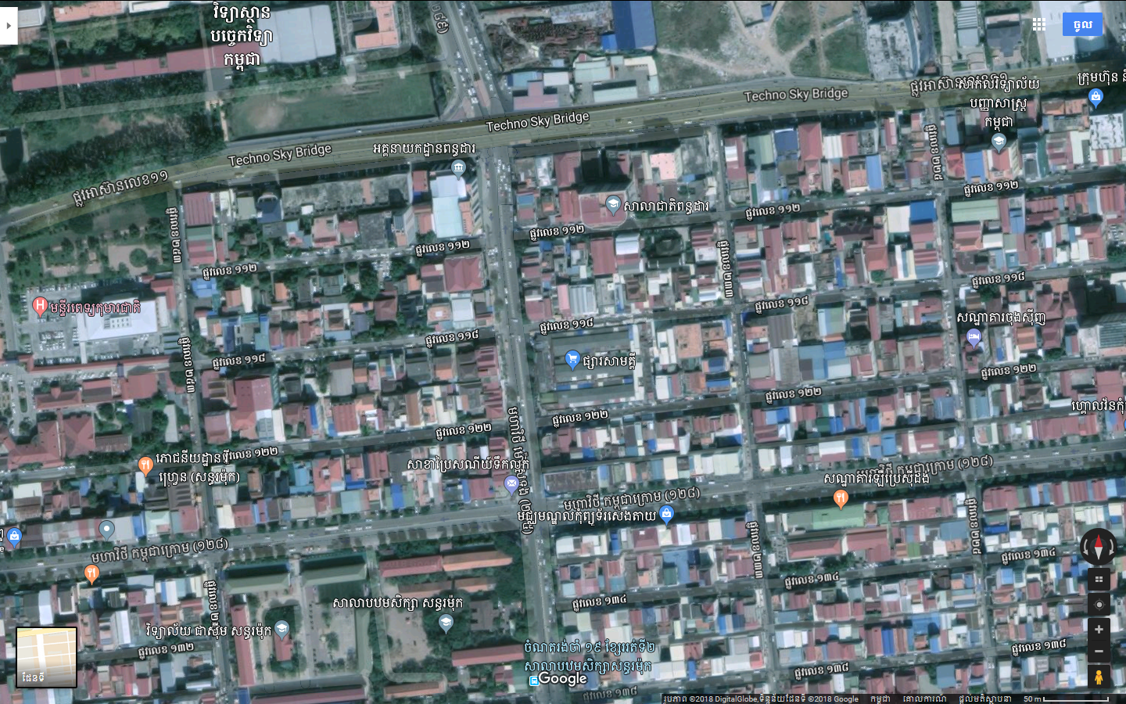

**Samakky Market**

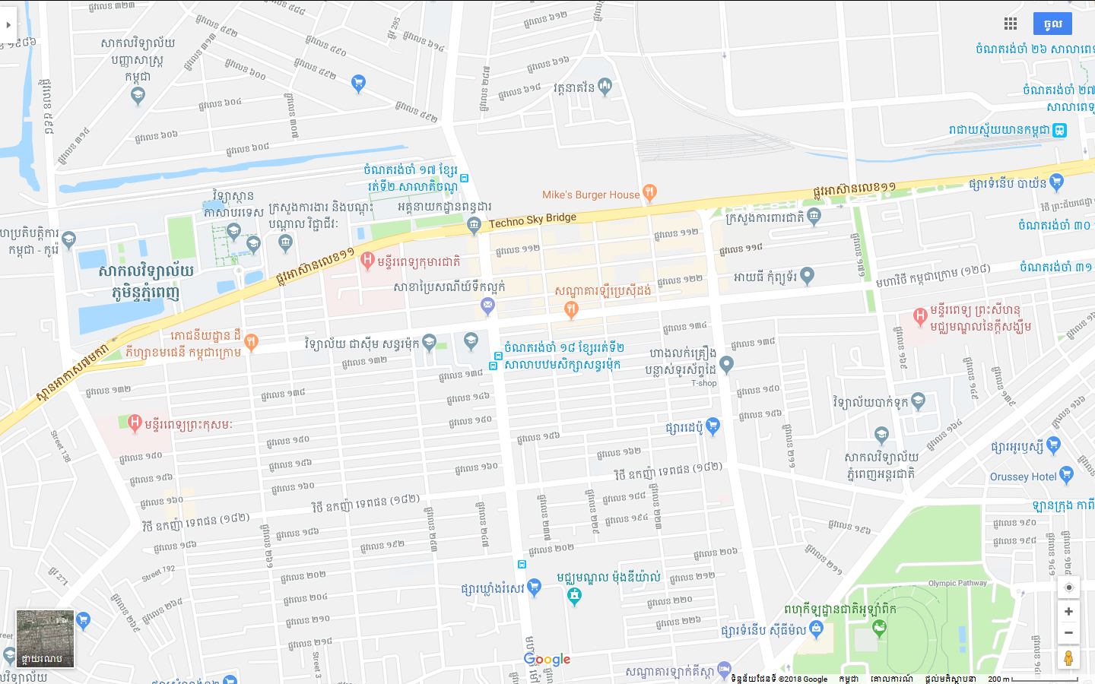

**Samakky Market**

